**LAB VIVA-1**

**LOGO:**

**Step1:** Open GIMP, Open an image as a layer.

**Step2:** Select text and write text.

**Step3:** Select move and move your text.

**Step 4:** Select align and align text in center.

**Step5:** Repeat, step 2 to Step 4 to enter and edit another text.

**Step6:** Save file and the logo is ready.

OUTPUT:

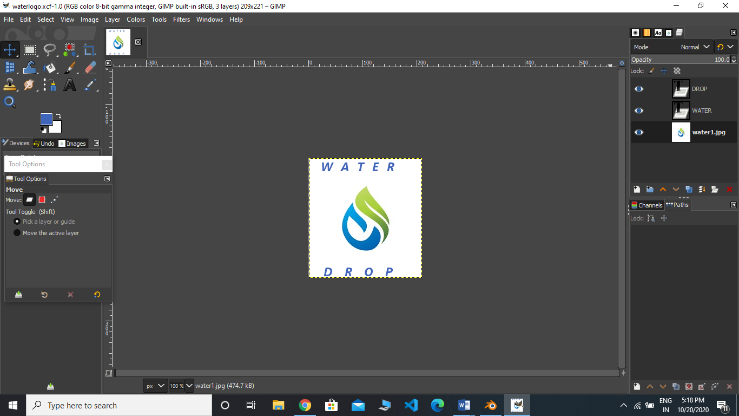

**SANITIZER:**

**Step1:** Open Blender, Create a blank file.

**Step2:** Add a Cylinder and scale it.

**Srep3:** Go to edit mode, select upper face and press E to extrude it.

**Step4:** Press S and scale down the upper face and then extrude it little.

**Step5:** Go to object mode, add another Cylinder and bring it up.

**Step6:** Edit and select upper face by P and make it little bigger and fix it.

**Step7:** Then go to particle properties and range emitter amount and velocity.

**Step8:** Add force to make it spray properly.

**Step9:** Now go to world property and color it.

**Step10:** Sanitizer bottle is ready to use.

OUTPUT:

